|  |  |
| --- | --- |
| **UFCFHQ-45-3 Comprehensive Creative Technologies Project:**  **Initial Proposal** | |
| Student Name: | Luke Hammond |
| Student Number: | 21013675 |
| Award: | Digital Media |
| Provisional project title: | Transferrable UI Across Game Platforms |

# Description

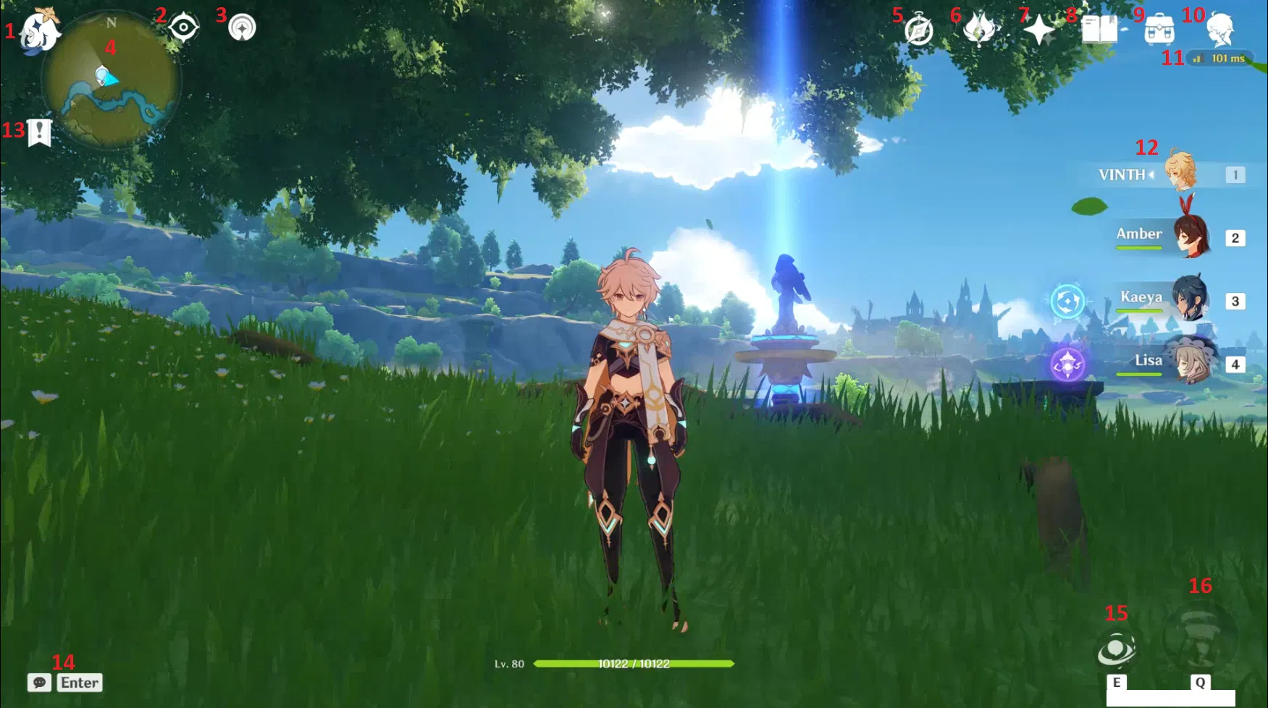My project will outline the importance of a transferable User Interface (UI) system for games between platforms. In this case the UI will be exclusive to the menus but will take into account Gaming Experience (GX) and User Experience (UX). As someone who plays games, I can empathise with how frustrating it can be to move from one platform to another “not understanding the differences between these platforms can cause difficulties and dissatisfaction for the end users” (Mori, 2019).

Figure 1 - Image showcasing Genshin Impact UI on PC.

Therefore, I am to recommend an improved UI, specifically a menu, for a pre-existing game that is available across multiple platforms. Ultimately, I want my work to be viewed as a recommendation based on evidence and user testing to be used as a tool to aid developers in creating an easily transferrable interface for the main methods of gaming: Console, PC and Mobile Phone.

**Deliverables/Outputs:**

* Documentation of User Testing
* Transcripts of Interviews
* Data Matrices
* Data Visualization of Interviews and User Testing
* Wireframing of Game Menu
* Game Menu Prototype Created in Figma
* Progress Diary
* Report
* Explainer Video and Script

# Background

There is little research into this field, at least not many that have gained traction, for that reason I view this as an opportunity to produce work for a low populated field and hopefully stand out with my discoveries. However, with the few works I did find, they helped guide me in a direction I could expand upon the research they have undertaken as well as find my footing in the field with my own project.

One such example is Peacocke, they performed user testing for a first-person shooter game. While the report doesn’t follow the same line of UI thinking as mine, it opened my eyes to other factors of consideration such as diegetic vs non diegetic displays as well as linking me to other great reads for further research. In Peacocke’s work they gave an outline of their user testing, which has had influence on my methodology but mine will further build upon their methods as well as incorporating new factors altogether such as the use of focus groups and surveys for more quantitative research.

In addition to Peacocke’s work was Hana Mori’s report on “Multi-Platform Game UI Design”. This report is the closest artifact I have found in correlation to my own project, within it is an abundance of research which I aim to utilise as secondary research to further solidify my primary research. This will help showcase the significance of my artifact and the importance of my project.

# Objectives

**Project Objectives: (What do I want to do? What is it I am doing?)**

* Create an effective and accessible UI menu
* Collect and Record data from participants
* Create a visual representation of data in the form of graphs and data matrices
* Create an intricate wireframe that is understandable by all viewers
* Perform successful examples of user testing

**Research Objectives: (What research do I want to achieve?)**

* Further research into effective UI systems for video games
* Further research into accessibility of UI system for cross-platform video games
* What the most effective UI system is for each platform
* Expand my understanding of user testing and the various methods you can incorporate

**Learning Objectives: (What do I want to learn by the end of this project?)**

* How to utilise Figma efficiently and effectively for the best output
* What the process is behind creating an accessible UI system
* How to create an accessible UI system
* How to perform informative user testing

# Methodology

This project will be a hybrid of qualitative and quantitative research which I will conduct in a variety of forms. For my quantitative research I want to spread a survey around for people to complete for more minor information I can get from numerous sources. This will help me in focusing in on key components for my final artifact as well as help shape my questions for interviews. That being the case, my qualitative research will involve interviews as well as focus groups for more in-depth and specific information after participants have partaken in recorded sessions of playing games. The benefit of these methods is the ability for users to bounce ideas between one another and see what a collective think together and perhaps coming up with an answer in unison, “focus groups often bring out users’ spontaneous reactions and ideas” (Nielsen, 1997).

An integral part of my methodology is the user testing; I will have participants play a variety of games on different consoles before ultimately playing one title on numerous devices. While participants play, I will have setup an eye tracker as well as have them speak their thoughts aloud to follow their process. The addition of an eye tracker means I can analyse what decisions people were making when perusing the menu while speaking aloud “serves as window on the soul, letting you discover what users really think” (Nielsen, 2012). The data I collect will help me in wire framing my work and be a great addition of help alongside established UX laws. From this work I hope to expand my understanding of UX, and the various ways research can be conducted.

Subsequently, I will combine both my primary and secondary research which will aid in creating a wireframe for a pre-existing game on paper, before transferring it to Figma. Throughout all these steps I will have participants trial my work for a consistent stream of feedback to create the best interface. My final output should be a reflection of my growth in using Figma and my understanding of accessibility within a UI.

This methodology will be a grand showcase of my UX skills accumulated since starting Digital Media, as I will be displaying my comprehension on a lot of theories such as Don Norman’s *Human Centred Design* or the *Gestalt Principles*. As well as my understanding of more practical skills; for example, user personas, user testing, data matrices and interviews.

In addition to this, I will be incorporating other teachings from previous modules such as Graphic and Web Design to create new icons as well as my understanding of accessibility in creating content.

# Specialist Resources and Support Required

For this project I will be using Figma and an eye tracking software. No support will be required.

# Project Plan

|  |  |  |
| --- | --- | --- |
| **Month** | **Task** | **Days** |
| October | Create initial Proposal  Research into the Field  Create full Proposal  Soft Submission of Proposal  Submit Proposal  Find Games to Analyse | 2  2  3  1  1  3 |
| November | Analyse Games  Create Tasks for Participants  Create a Contract and GDPR Form  Conduct Tests, Interviews and Focus Group | 3  2  1  18 |
| December | Visualise Data  Transcripts  Data Matrices  Research into UX Laws  Wireframing | 3  3  3  1  7 |
| January | Design Poster  User Testing  Figma  Soft Submission of Poster  Submit Poster  Poster Presentation | 7  3  14  1  1  1 |
| February | User Testing  Data Visualisation | 14  3 |
| March | Figma  Report | 7  21 |
| April | Report  Video  Soft Submission of Project  Submission of Project | 21  3  1  1 |
| May | Viva | 1 |

# Sources and References

Game Maker’s Toolkit (2021). The Power of Video Game HUDs. *YouTube* [video]. 29 April. Available from: <https://www.youtube.com/watch?v=4Bv45aPMGyI> [Accessed 09 October 2023].

HoYoLAB (2022) *In-Game UI Explanation.* Available from: <https://www.hoyolab.com/article/5921298> [Accessed 25 October 2023].

Jorgensen, K. Llanos, SC. (2011) *Do Players Prefer Integrated User Interfaces? A Qualitative Study of Game UI Design Issues* [online]. Report number: . DiGRA. Available from: <http://www.digra.org/wp-content/uploads/digital-library/11313.34398.pdf> [Accessed 06 October 2023].

Jorgensen, K. (2012) Between the Game System and the Fictional World: A Study of Computer Game Interfaces*. Games and Culture: A Journal of Interactive Media* [online]. 7 (2). [Accessed 06 October 2023].

Kristiadi, DP. Udjaja, Y. Supangat, B. Prameswara, RY. Warnars, HLHS. Heryadi, Y. Kusakunniran, W. (2018) *The effect of UI, UX and GX on video games* [online]. Report number: 17618073. IEEE. Available from: <https://ieeexplore.ieee.org/abstract/document/8311702> [Accessed 06 October 2023].

Mori, H. (2019) *Approach to multi-platform game UI design* [online]. XAMK. Available from: <https://www.theseus.fi/bitstream/handle/10024/167129/Mori_Hana.pdf?sequence=2&isAllowed=y> [Accessed 07 October 2023].

Nielsen, J. (2012) Thinking Aloud: The #1 Usability Tool. *Nielsen Norman Group* [online]. [Accessed 24 October 2023].

Nielsen, J (1997) The Use and Misuse of Focus Groups. *Nielsen Norman Group* [online]. [Accessed 24 October 2023]

Peacocke, M. Teather, RJ. Carette, J. MacKenzie, IJ. McArthur, V. (2018) An empirical comparison of first-person shooter information displays: HUDs, diegetic displays, and spatial representations. *Entertainment Computing* [online] 26, pp. 41-58. [Accessed 06 October 2023].

Playbookux (2023) *Why are Focus Groups in User Experience Research?.* Available from: <https://www.playbookux.com/what-are-focus-groups-in-user-experience-research/> [Accessed 25 October 2023].

Razbuten (2022). What Elden Ring Is Like For Someone Who Doesn’t Play Games. *YouTube* [video]. 31 December. Available from: <https://www.youtube.com/watch?v=WamFLD7Y2-4&t=861s> [Accessed 07 October 2023].

ScienceDirect (2023) *User Interface Design*. Available from: <https://www.sciencedirect.com/topics/computer-science/user-interface-design> [Accessed 07 October 2023].

Yin, P. (2019) *Research on Design and Optimization of Game UI Framework Based on Unity3D* [online]. Report Number: 19359798. IEEE. Available from: <https://ieeexplore.ieee.org/document/8990972> [Accessed 06 October 2023].